**Practical no-2**

**Design a distributed application using RMI for remote computation where client submits two strings to the server and server returns the concatenation of the given strings.**

In Python, you can use the **Pyro4 library to implement a distributed application using RMI (Remote Method Invocation) for remote computation. Pyro4 is a Python Remote Objects library that simplifies the process of building distributed applications.**

Before you start, you need to install the Pyro4 library. You can install it using:

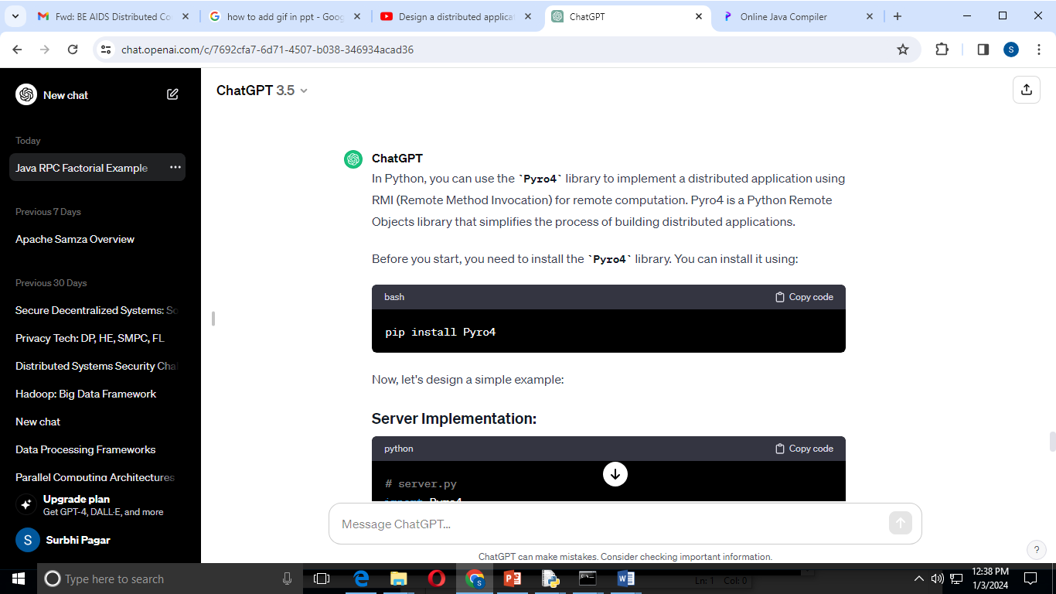

**Server Implementation:**

**# server.py**

import Pyro4

@Pyro4.expose

class StringConcatenationServer:

def concatenate_strings(self, str1, str2):

result = str1 + str2

return result

def main():

daemon = Pyro4.Daemon() **# Create a Pyro daemon**

ns = Pyro4.locateNS() **# Locate the Pyro nameserver**

**# Create an instance of the server class**

server = StringConcatenationServer()

**# Register the server object with the Pyro nameserver**

uri = daemon.register(server)

ns.register("string.concatenation", uri)

print("Server URI:", uri)

with open("server_uri.txt", "w") as f:

f.write(str(uri))

daemon.requestLoop()

if __name__ == "__main__":

main()

### Client Implementation:

**# client.py**

import Pyro4

def main():

with open("server_uri.txt", "r") as f:

uri = f.read()

server = Pyro4.Proxy(uri) **# Connect to the remote server**

str1 = input("Enter the first string: ")

str2 = input("Enter the second string: ")

result = server.concatenate_strings(str1, str2)

print("Concatenated Result:", result)

if __name__ == "__main__":

main()

**Steps to Run:**

**Install Pyro4 library**

**Then Use command Pyro4-ns**

**And use following steps**

**1)Save the server code in a file, e.g., server.py**

**2)Save the client code in a file, e.g., client.py**

**3)Open a terminal and run the server: python server.py**

**4)you will get server uri paste it inserver_uri.txt file.keep it in same folder where you have stored python files.**

**5)Open another terminal and run the client: python client.py**

**6)enter the values for concatenation.**

This example demonstrates a basic setup for using Pyro4 to create a distributed application for string concatenation. Adjust the strings in the client code as needed. Note that this is a simple example, and in a real-world scenario, you might want to handle exceptions, error checking, and security considerations.

Reference Link: <https://www.javatpoint.com/RMI>